**G20 GDP growth slows to 0.7% in the second quarter of 2023**

Paris, 14 September 2023

Reference period: 2nd Quarter 2023

**Gross domestic product (GDP) in the G20 area grew by 0.7% quarter-on-quarter** **in the second quarter of 2023** according to provisional estimates, down from 1.0% in the previous quarter (Figure 1).

**The slowdown in the G20 area in Q2 2023 mainly reflected a deceleration of the economy in China**,[1] where GDP growth slowed to 0.8% compared with 2.2% in the previous quarter. **A decline in G20 merchandise trade in Q2 2023**[2] **also contributed to the** **G20 economic slowdown.** Growth also slowed in Brazil (to 0.9% in Q2, compared with 1.8% in Q1) and to a lesser extent in India (to 1.9%, compared with 2.1%). In Canada and the European Union, zero growth was recorded in Q2 2023, after GDP grew by 0.6% and 0.2% respectively in the previous quarter. Furthermore, GDP decreased in Italy (by 0.4% in Q2 2023), as well as in Saudi Arabia (by 0.1%).

Despite the slower growth in the G20 area as a whole, GDP grew strongly in Türkiye in Q2 2023 (by 3.5%, compared with a contraction of 0.1% in Q1), mainly reflecting an acceleration of private consumption (5.2% in Q2, compared with 3.0% in Q1). Growth also increased in France, Japan, Korea, South Africa and the United Kingdom. In Germany, there was zero GDP growth in Q2 2023 after two quarters of contraction. Compared with the first quarter, growth remained unchanged in Indonesia and Mexico (at 0.8% in both countries), in the United States (at 0.5%), and in Australia (at 0.4%).

In Q2 2023, **GDP in the G20 area exceeded its pre-pandemic (Q4 2019) level by 8.8%** (Figure 2). However, in the United Kingdom, GDP remained below its pre-pandemic level by 0.2%.

 **Figure 1 – Gross domestic product (quarter-on-quarter change)**

Percentage change on the previous quarter, seasonally adjusted data

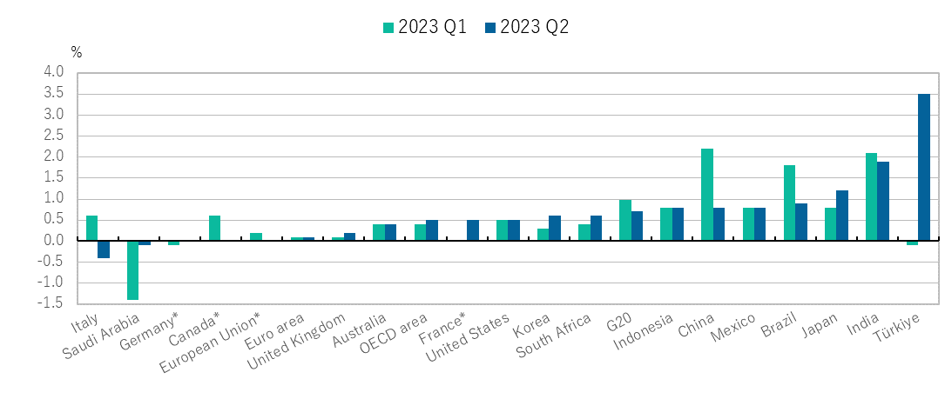

* In Q2 2023, Canada, Germany and the European Union recorded zero growth. In Q1 2023, France recorded zero growth.

Visit the interactive [OECD Data Portal](https://data.oecd.org/gdp/quarterly-gdp.htm) to explore this data

data

 **Figure 2 – Gross domestic product (change since Q4 2019)**

Cumulative growth rate (percentage), seasonally adjusted data

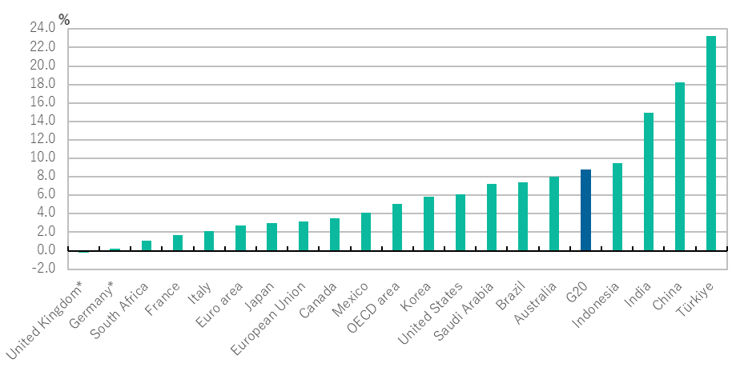

* In Q2 2023, the United Kingdom recorded a cumulative growth rate of minus 0.2% and Germany recorded 0.2%.

**Table 1 – Quarterly (quarter-on-quarter) real GDP growth**

*Percentage change on the previous quarter, seasonally adjusted data*

|  |  |  |  |  |  |  |  |  |  |  |
| --- | --- | --- | --- | --- | --- | --- | --- | --- | --- | --- |
|  | **2021** | | | **2022** | | | | **2023** | | **cumulative growth  Q4 2019 to Q2 2023** |
|  | **Q2** | **Q3** | **Q4** | **Q1** | **Q2** | **Q3** | **Q4** | **Q1** | **Q2** |
| **G20** | 1.6 | 0.9 | 1.5 | 0.5 | 0.0 | 1.3 | 0.4 | 1.0 | 0.7 | 8.8 |
| **Argentina** | -0.2 | 2.9 | 2.5 | 0.6 | 1.4 | 0.8 | -1.7 | 0.7 | .. | .. |
| **Australia** | 0.7 | -2.1 | 3.9 | 0.6 | 0.7 | 0.7 | 0.7 | 0.4 | 0.4 | 8.0 |
| **Brazil** | -0.2 | 0.4 | 1.1 | 0.9 | 1.0 | 0.4 | 0.1 | 1.8 | 0.9 | 7.4 |
| **Canada** | -0.6 | 1.4 | 1.7 | 0.6 | 0.9 | 0.6 | 0.0 | 0.6 | 0.0 | 3.5 |
| **China** | 1.3 | 0.7 | 1.6 | 1.0 | -1.9 | 3.2 | 0.5 | 2.2 | 0.8 | 18.2 |
| **France** | 0.9 | 3.0 | 0.6 | -0.1 | 0.4 | 0.3 | 0.1 | 0.0 | 0.5 | 1.7 |
| **Germany** | 2.2 | 0.7 | 0.0 | 1.0 | -0.1 | 0.4 | -0.4 | -0.1 | 0.0 | 0.2 |
| **India** | -7.5 | 9.3 | 2.0 | 0.5 | 0.9 | 2.0 | 1.1 | 2.1 | 1.9 | 14.9 |
| **Indonesia** | 0.3 | 0.0 | 3.2 | 1.0 | 0.9 | 0.8 | 2.3 | 0.8 | 0.8 | 9.5 |
| **Italy** | 2.5 | 2.9 | 0.8 | 0.1 | 1.2 | 0.3 | -0.2 | 0.6 | -0.4 | 2.1 |
| **Japan** | 0.5 | -0.4 | 1.1 | -0.6 | 1.3 | -0.3 | 0.1 | 0.8 | 1.2 | 3.0 |
| **Korea** | 0.9 | 0.1 | 1.4 | 0.7 | 0.8 | 0.2 | -0.3 | 0.3 | 0.6 | 5.9 |
| **Mexico** | 0.7 | -0.6 | 1.4 | 1.4 | 1.0 | 1.2 | 0.6 | 0.8 | 0.8 | 4.1 |
| **Russian Federation** |  |  |  |  |  |  |  |  |  |  |
| **Saudi Arabia** | 1.8 | 4.3 | 2.4 | 2.7 | 1.1 | 1.2 | 1.3 | -1.4 | -0.1 | 7.2 |
| **South Africa** | 1.3 | -1.9 | 1.4 | 1.5 | -0.8 | 1.8 | -1.1 | 0.4 | 0.6 | 1.1 |
| **Türkiye** | 1.7 | 3.6 | 1.6 | 0.2 | 1.4 | 0.5 | 1.1 | -0.1 | 3.5 | 23.3 |
| **United Kingdom** | 6.5 | 1.7 | 1.5 | 0.5 | 0.1 | -0.1 | 0.1 | 0.1 | 0.2 | -0.2 |
| **United States** | 1.7 | 0.7 | 1.7 | -0.4 | -0.1 | 0.8 | 0.6 | 0.5 | 0.5 | 6.1 |
| **European Union** | 2.0 | 2.1 | 0.7 | 0.7 | 0.7 | 0.3 | -0.1 | 0.2 | 0.0 | 3.1 |
| **of which: Euro area** | 2.0 | 2.1 | 0.5 | 0.7 | 0.8 | 0.3 | -0.1 | 0.1 | 0.1 | 2.7 |
| **OECD area** | 1.8 | 1.2 | 1.4 | 0.2 | 0.5 | 0.5 | 0.2 | 0.4 | 0.5 | 5.1 |

..: not available  
Note: The Russian Federation is included in the G20 estimates, but it is not shown separately. From Q4 2021, GDP figures for Russia are not included, as reliable estimates are not available, and the G20 totals are reweighted accordingly.

Source: OECD (2023) [Quarterly National Accounts (Database)](https://stats.oecd.org/index.aspx?queryid=33940)

**Table 2 – Quarterly (year-on-year) real GDP growth**

*Percentage change on the same quarter of the previous year, seasonally adjusted data*

..: not available  
Note: The Russian Federation is included in the G20 estimates, but it is not shown separately. From Q4 2021, GDP figures for Russia are not included, as reliable estimates are not available, and the G20 totals are reweighted accordingly.

Source: OECD (2023) [Quarterly National Accounts (Database)](https://stats.oecd.org/index.aspx?queryid=33940)

Data shown in this release was last updated on the 8th of September 2023.

**Methodological information:**

G20 GDP growth – [Methodological Notes for G20 GDP News Release](http://www.oecd.org/sdd/na/G20QuarterlyGDPGrowth_Methodology.pdf).

OECD GDP growth – [Methodological Notes for OECD GDP News Release](http://www.oecd.org/sdd/na/OECDQuarterlyGDPGrowth_Methodology_EN.pdf).

**Access Data:**

OECD Database:[G20 GDP News release underlying data](https://stats.oecd.org/index.aspx?queryid=33940); [G7 countries and OECD aggregates, GDP and components, growth and contributions to growth](https://stats.oecd.org/index.aspx?queryid=25673); [OECD countries, GDP growth](https://stats.oecd.org/index.aspx?queryid=350).

**Contacts:**

For further information contact the OECD's Media Relations Division on (33) 1 45 24 97 00 or e-mail [news.contact@oecd.org](mailto:news.contact@oecd.org); for further information on data contact OECD’s Statistics and Data Directorate: [stat.contact@oecd.org](mailto:stat.contact@oecd.org).

[Next releases](https://www.oecd.org/sdd/na/release-dates-oecd-news-releases-quarterly-national-accounts.htm)**:**

OECD GDP growth – Q3 2023: [21 November 2023](https://www.oecd.org/sdd/na/release-dates-oecd-news-releases-quarterly-national-accounts.htm)

G20 GDP growth – Q3 2023: [14 December 2023](https://www.oecd.org/sdd/na/release-dates-oecd-news-releases-quarterly-national-accounts.htm)

1. China’s nominal GDP represented 23.2% of G20 GDP in 2021 (see Annex table 1 in the [methodological note](http://www.oecd.org/sdd/na/G20QuarterlyGDPGrowth_Methodology.pdf)).
2. Please refer to the [OECD G20 international trade statistics](https://www.oecd.org/sdd/its/International-trade-statistics-Q2-2023.pdf) issued on 24 August 2023 and [underlying data](https://data.oecd.org/trade/trade-in-goods.htm).